General Information

Insurance Information

Focus
What is your primary reason for seeking care at our office? What was the initial cause? When did it begin? What makes it worse? What makes it better?

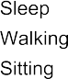
How does this problem interfere with your daily activities?
Standing
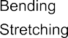
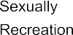
Emotional Relationships Social Life
What have you done about this?

Are you interested in:

What are your health goals?

List any past or future surgeries.

List any significant trauma. When did it occur? (auto accident, falls, emotional, sexual, etc...)

List exercise and sport activities you have been or are currently involved in:

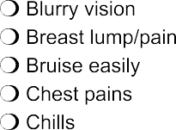
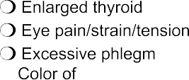
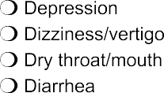
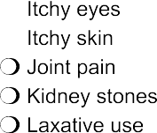
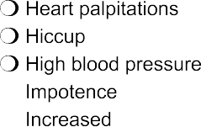
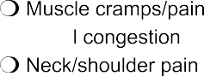
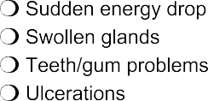
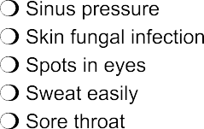
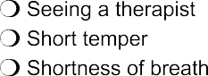
Signs/Symptoms

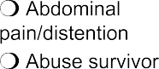

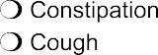
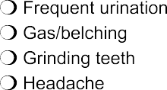
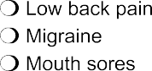
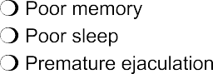
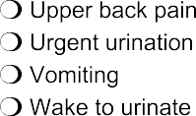
Female Concerns

Medical History

Do you have any allergies? Yes No If so, to what? Do you take medication? Yes No If so what types and how often Do you take supplements? Yes No If so what types and how often

Web of Wellness
9
8
4
3
Mental Health
Physical Health

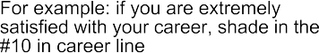
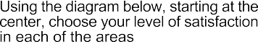
Sexual Health
10
7
6
5
10
9
8
7
6
5
4
3

Career Health
8
7
6
8
7
6
10
9
8
7
6
5
4
3
Financial Health

Spiritual Health
10
9
8
7
6
5
4
3
2
1
10
9
8
7
6
5
4
3
10
9
8
7
6
5
4
3

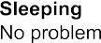
Pain

Social Health
10
9
5
4
3

Family Health
10
9
5
4
3

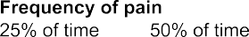
2
2
2
2
2
2
2

INFORMED CONSENT FOR ORIENTAL MEDICAL TREATMENT

I hereby request and consent to the performance of acupuncture treatments and other procedures within the scope of practice of Oriental medicine on me (or on the patient named below for whom I am legally responsible) by the licensed acupuncturists named below and/or other licensed acupuncturists who now or in the future treat me while employed by, working or associated with, or serving as back-up for the
practitioners named below, including those working at Bodhi Acupuncture and Wellness, LLC or any other office or clinic, whether signatories to this form or not.

There are some risks to treatment, including but not limited to some bruising of the skin and/or slight bleeding. If moxibustion or heat therapies are used there is a risk of burn and/or scarring. The risk of infection is small when all needles are sterile and Clean Needle Technique procedures are followed. I
understand that all practitioners at Bodhi Acupuncture and Wellness, LLC are certified in Clean Needle Technique a use only sterile, single-use, disposable needles.

I have had an opportunity to discuss with the practitioner the nature and purpose of Oriental Medicine. I
understand that results are not guaranteed.

I do not expect the practitioner to be able to anticipate and explain all risks and complications. I wish to rely on the practitioner to exercise judgment which the practitioner feels at the time is in my best interest, based upon the facts then known, during the course of the procedure.

I understand that I have the choice to accept or reject the proposed diagnostic procedure or treatment, or any part of it, before or during the diagnosis or treatment.

I understand that the practitioner is not providing Western (allopathic) medical care, and that I should look to my Western primary care practitioner (i.e. MD) for those services and for routine check-ups.

I have read, or have had read to me, the above consent. I have also had an opportunity to ask questions about its content, and by signing below I agree to the above-named procedures. I intend this consent form to cover the entire course of treatment for my present condition and for any future condition(s) for which I seek treatment.

NOTICE OF PRIVACY PRACTICES

Our Clinic Protects Your Health Information and Privacy

Dear Valued Patient,

This notice describes our office’s policy for how medical information about you may be used and disclosed, how you can get access to this information, and how your privacy is being protected.

In order to maintain the level of service that you expect from our office, we may need to share limited personal medical and financial information with your insurance company, with worker’s compensation (and your employer as well in this instance), or with other medical practitioners that you authorize.

Safeguards in place at our office include:

• Limited access to facilities where information is stored.
• Policies and procedures for handling information.
• Requirements for third parties to contractually comply with privacy laws.
• All medical files and records (including email, regular mail, telephone, and faxes sent) are kept on permanent file.

Types of information that we gather and use:

• From your medical history, treatment notes, all test results, and any letters, faxes, emails or telephone conversations to or from other health care practitioners.
• About your financial transactions with us (billing transactions).
• From health care providers, insurance companies, worker’s compensation and your employer, and other third party administrators (e.g. requests for medical records, claim payment information).

We value our relationship and respect your right to privacy. If you have questions about our privacy guidelines, please call us during regular business hours at 515-512-6909

Best regards,

John Emanoil, L.Ac.. Dipl. Ac.

